**Deploying private Cloud using OpenStack on VirtualBox**

**Components used in the project**

| Component | Details |
| --- | --- |
| Host operating system | Ubuntu 14.04.3 (AMD 64bit) |
| Hypervisor | KVM/qemu |
| Database | MySQL |
| Message queue | RabbitMQ for Ubuntu |
| Networking service | nova-network |
| Single nova-network or multi-host? | multi-host |
| Image service (glance) back end | File |
| Identity (keystone) driver | SQL |
| Object storage | OpenStack Object Storage (swift) |
| Architecture | Nova |

**OpenStack:**

OpenStack is a cloud operating system that controls large pools of compute, storage, and networking resources throughout a datacenter, all managed through a dashboard that gives administrators control while empowering their users to provision resources through a web interface.

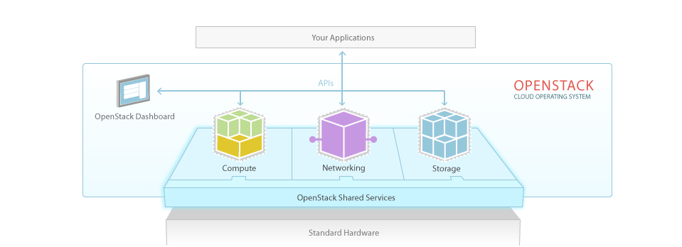

Reference: <http://www.openstack.org/software/>

**OpenStack architecture:**

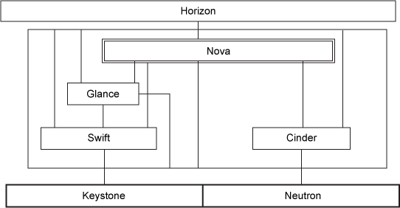

Reference: <http://www.ibm.com/developerworks/cloud/library/cl-openstack-overview/index.html>

Three elements interact with all the components in the system. Horizon is the graphical UI that administrators can most easily use to manage all the projects. Keystone handles the management of authorized users, and Neutron defines the networks that provide connectivity between the components.

Nova can arguably be considered the core OpenStack. It handles the orchestration of workloads. Its compute instances usually require some form of persistent storage which can be either block-based (Cinder) or object-based (Swift). Nova also requires an image to launch an instance. Glance handles this request, whereby it can optionally use Swift as its storage back end.

**ONTOLOGIES:**

**Keystone**:

It is an OpenStack identity service that manages the database (MySql in our case), API endpoints, service catalogs (contains compute (nova), image service (glance), storage (swift)) along with authentication services for multi users using username, password, token credentials.

It gives the user role, tenant (user groups), credentials to authenticate, and endpoints to access the services

**Glance:**

It can copy and store a server or disk image so that it provides when requested and new servers can be created instantly. It can store VM images in normal filesystems as well as object storage (swift) of OpenStack.

Glance has an API and a registry:

**API:** can attend calls for images, it discovers the requested image using registry and returns back

**Registry:** it stores the metadata about the image like size, type, etc. These metadata are stored in database provided by glance and the glance also supports filesystems of its own.

**Swift:**

It is the storage component of openstack. It provides redundant storage facilities to store backups, archives and Vms. So it helps in recovery and when a new cluster comes in, it provides the content instantly. The user can employ inexpensive disks and servers for this. Also helps in horizontal scaling by providing the contents to new servers added.

**Nova:**

It is the cloud computing services of openstack. It provides API for accessing form amazon, etc, gives a database for storing data as well as object storage for images, it is built on messaing service architecture like RabbitMQ so that it runs on several servers and helps communication between hypervisor and the Vms

It also helps in authentication managing, networking using bridges, vlans and shcedules hosts to Vms.

**Cinder:**

It handles the block level storages to Vms in order to expand their disk space when required. It manages well with database and file systems constraints. It improves performance.

**Neutron-network:**

This provides the networking capabilties of openstack, it lends the routers, subnets, LAN, IP configurations. It provides the LAN with vLAN, ipv6, dhcp and configure the internal topology. Also the floating IP s are used for providing external IP s for VMs.

**Horizon:**

Horizon is the graphical UI that administrators can most easily use to manage all the projects.

**Steps for Nova Architecture:**

**Setting up Controller node:**

**Keystone service list**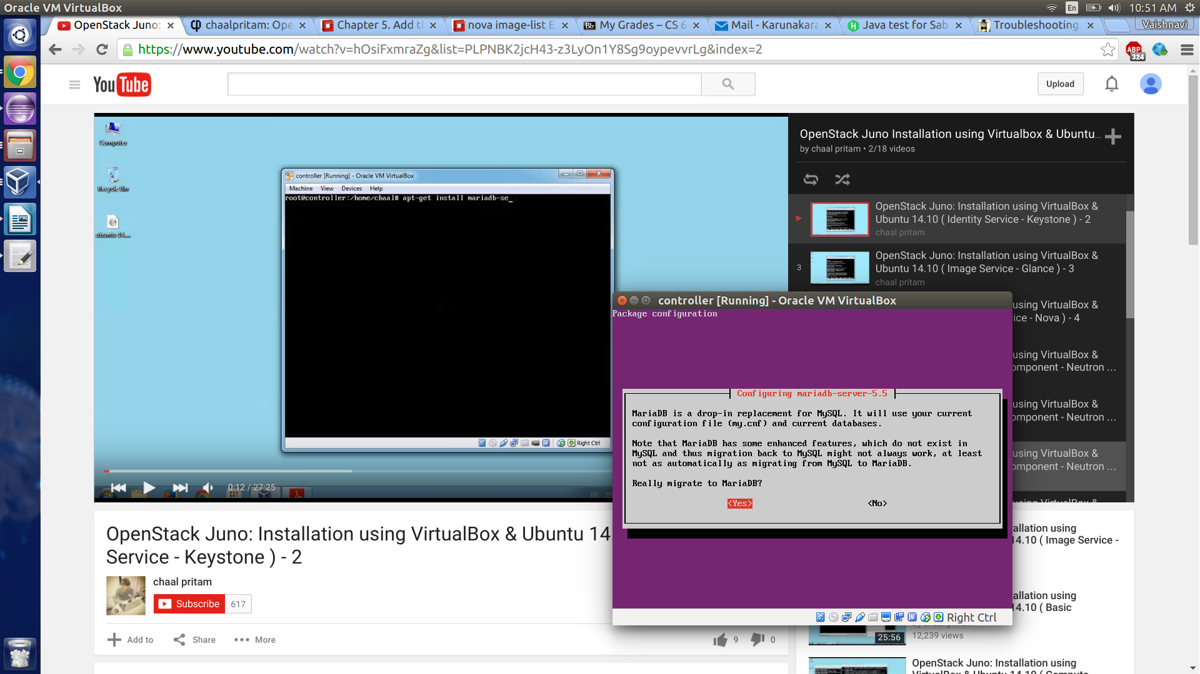

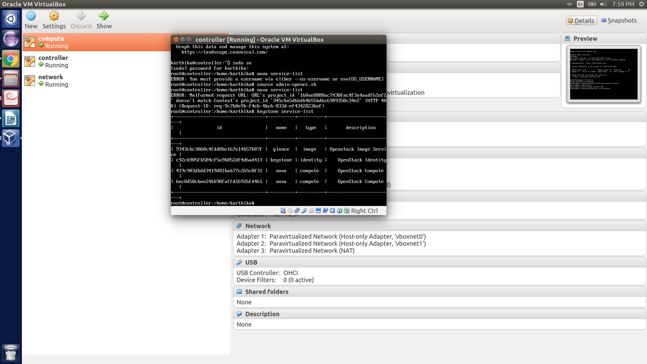

**Controller - Compute ping**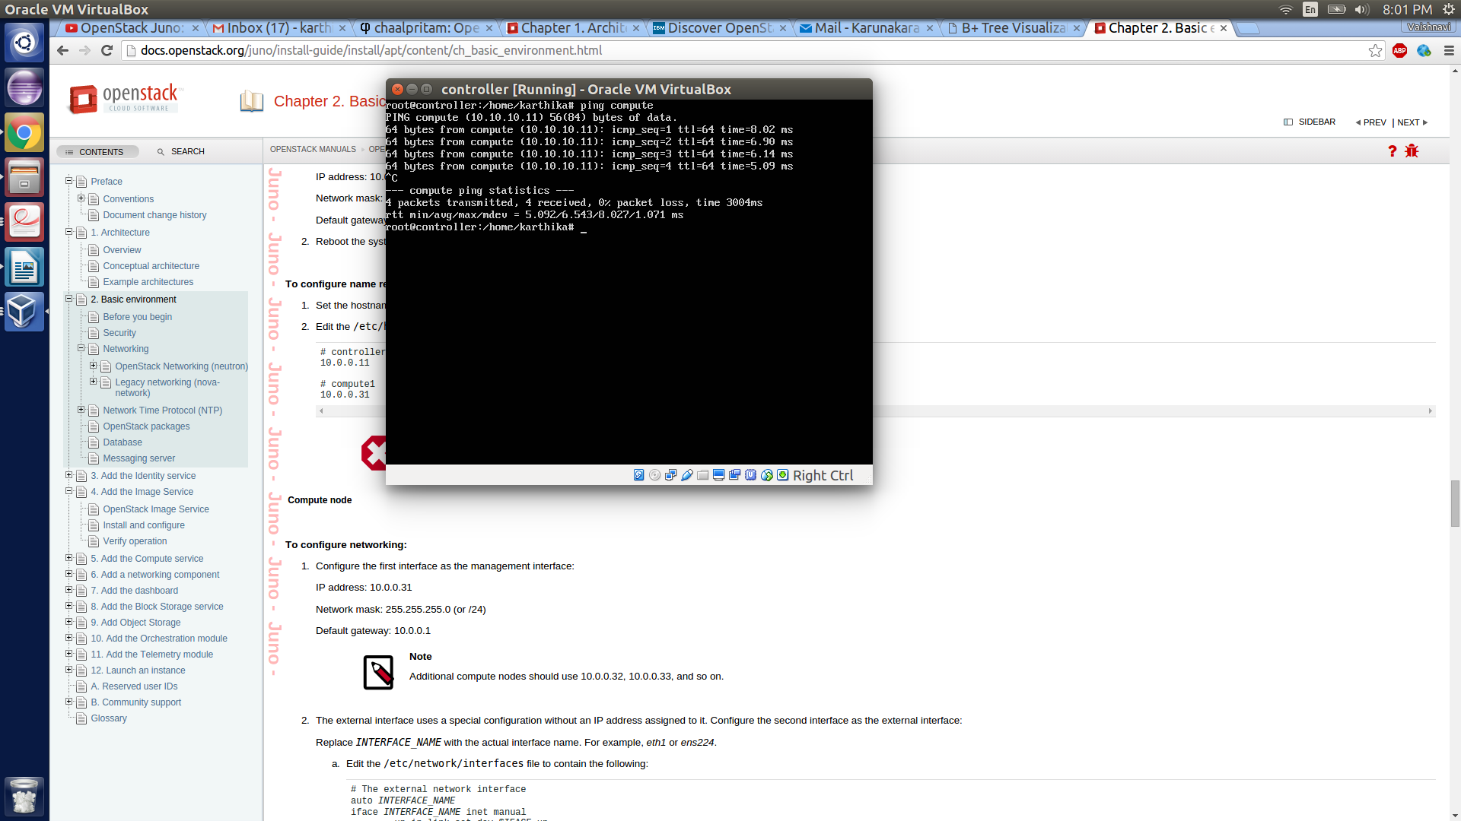

**Controller – network ping**

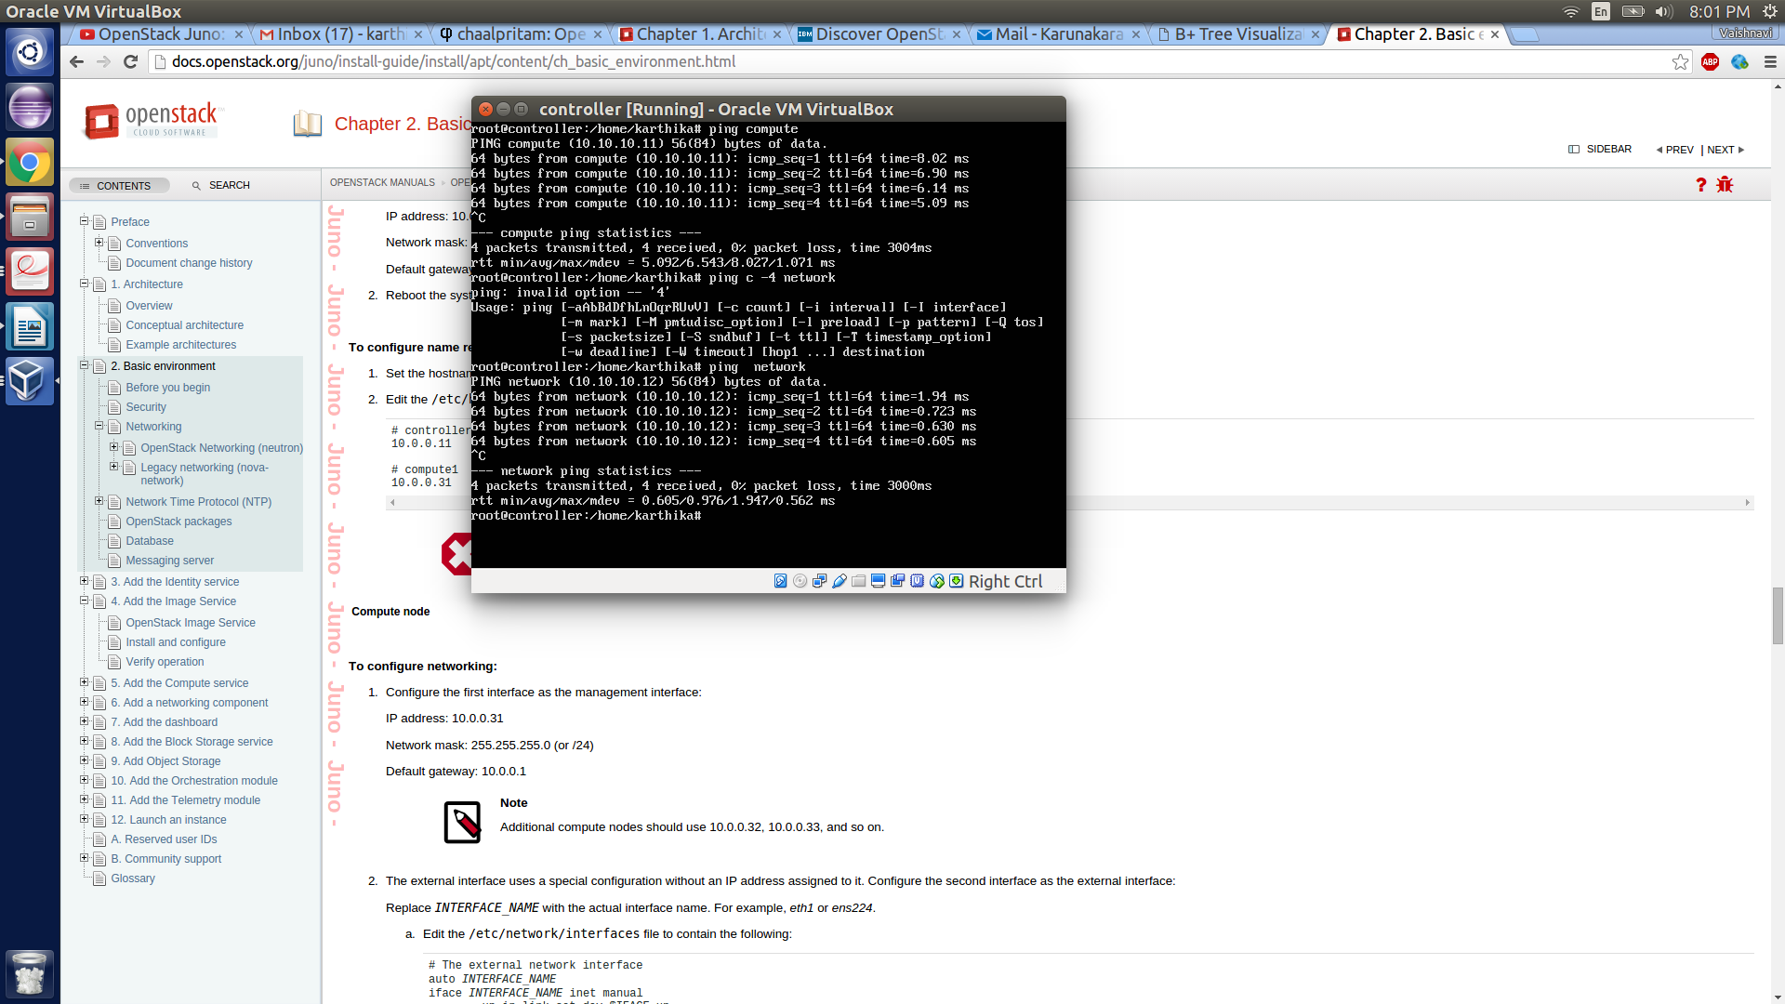

**Compute – controller ping**

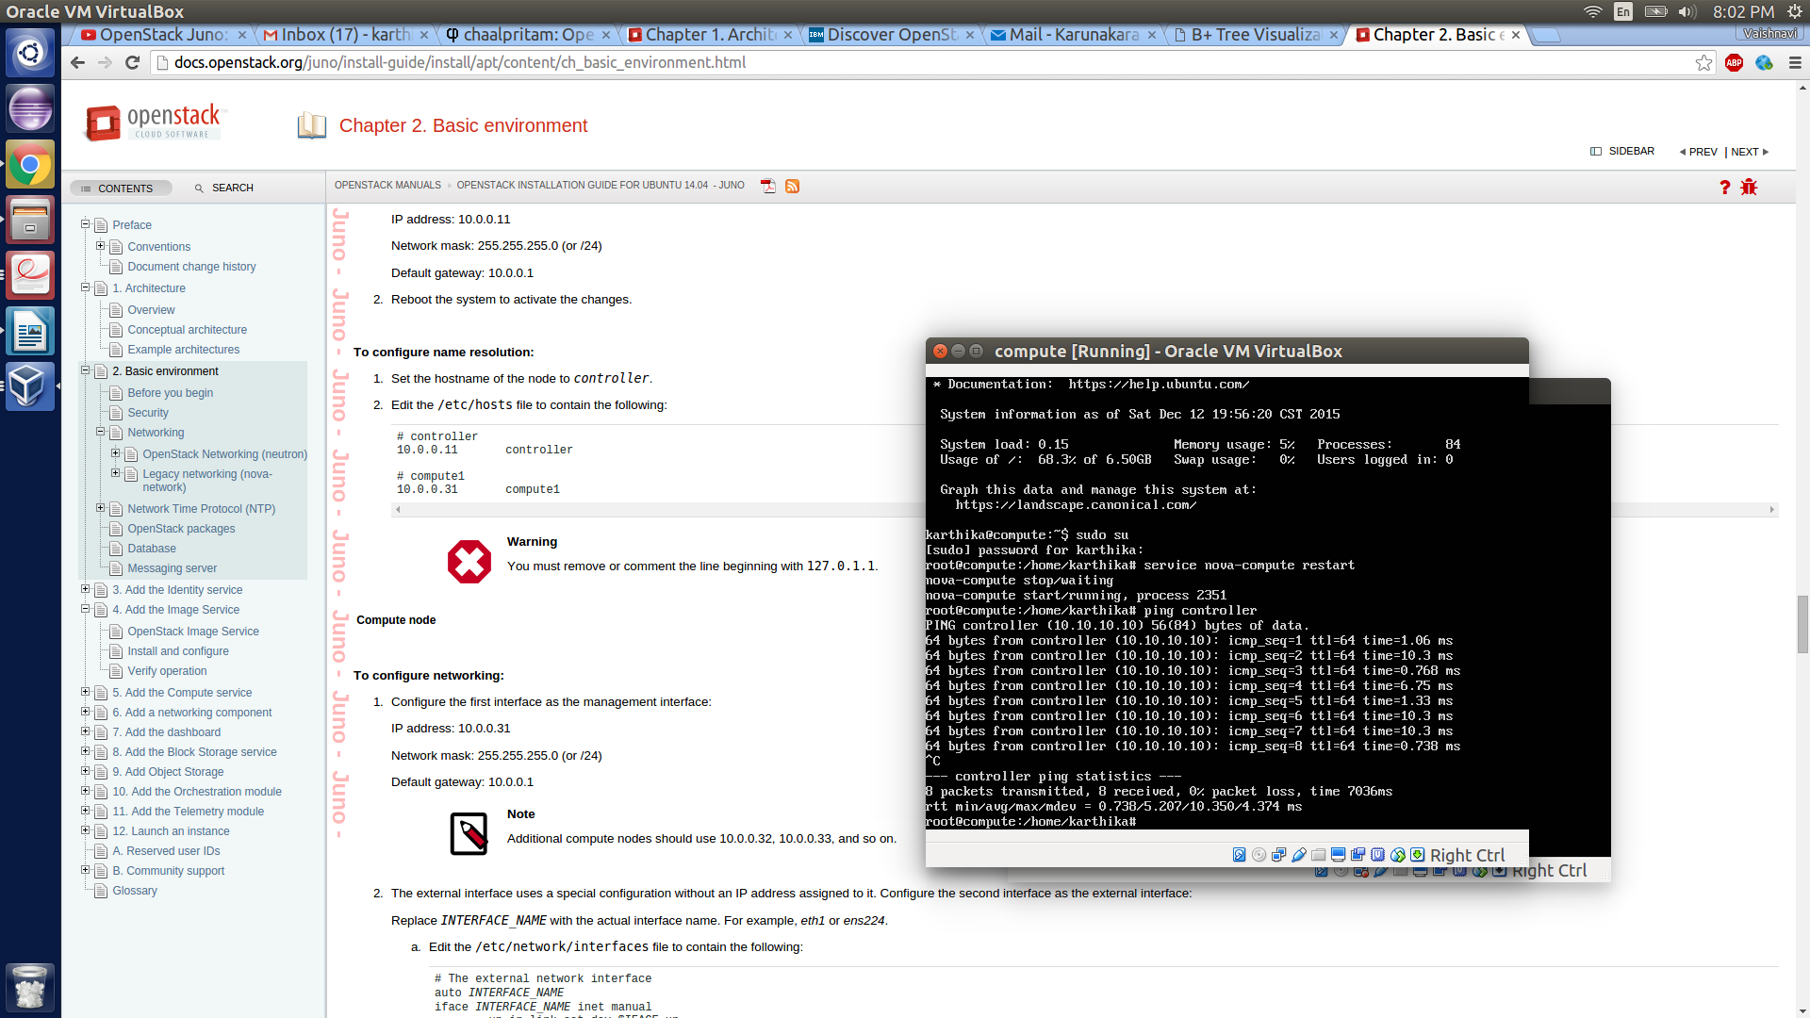

**Compute – network ping**

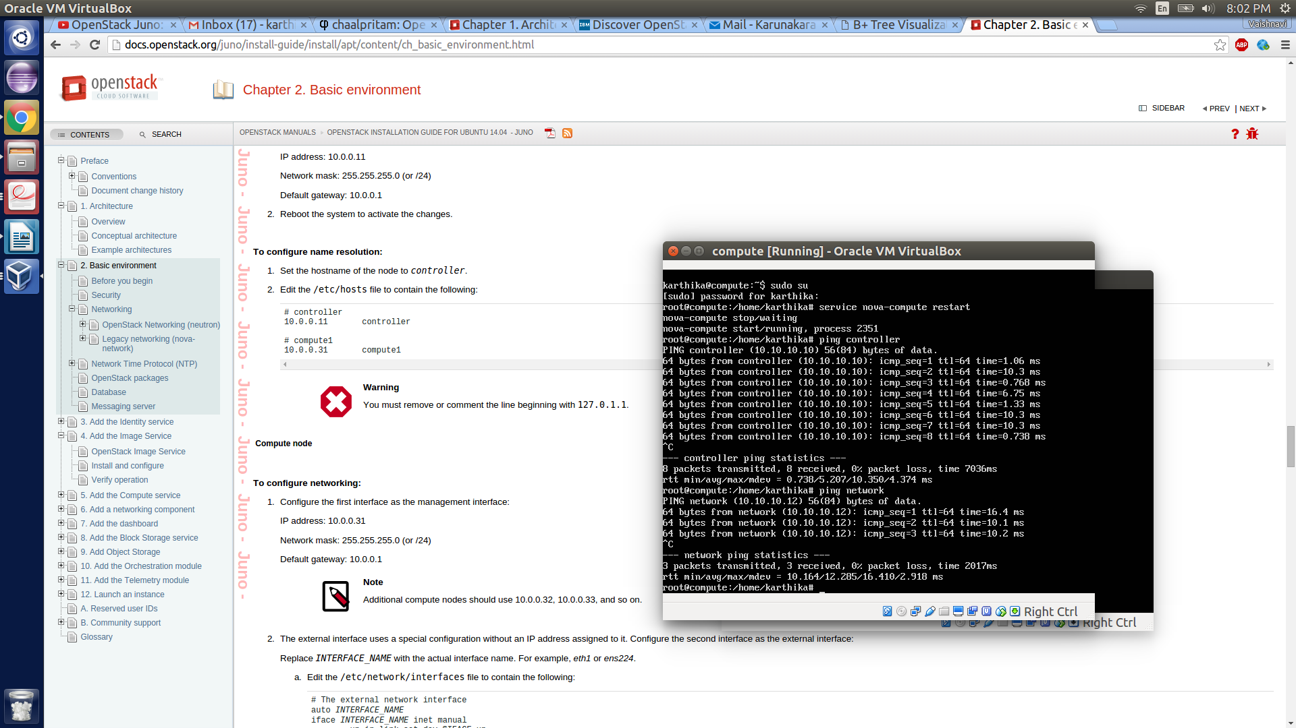

**Network – compute ping**

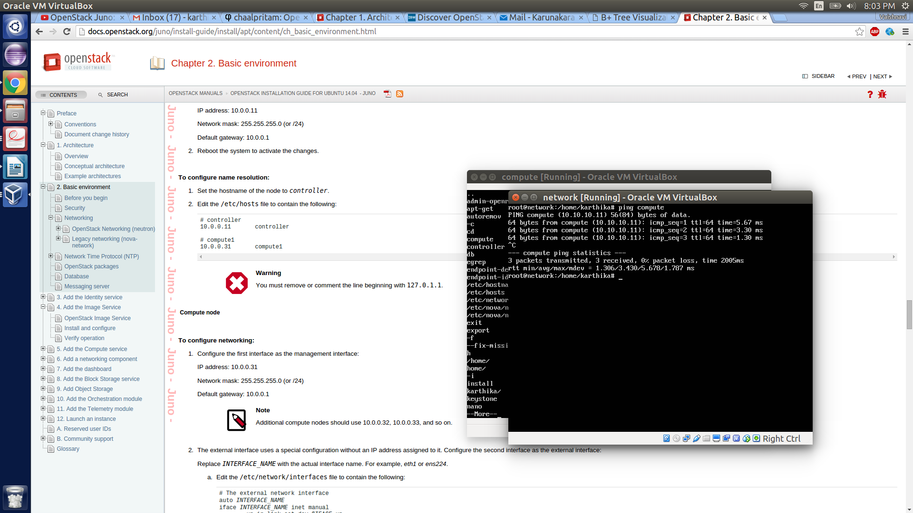

**Controller glance restart**

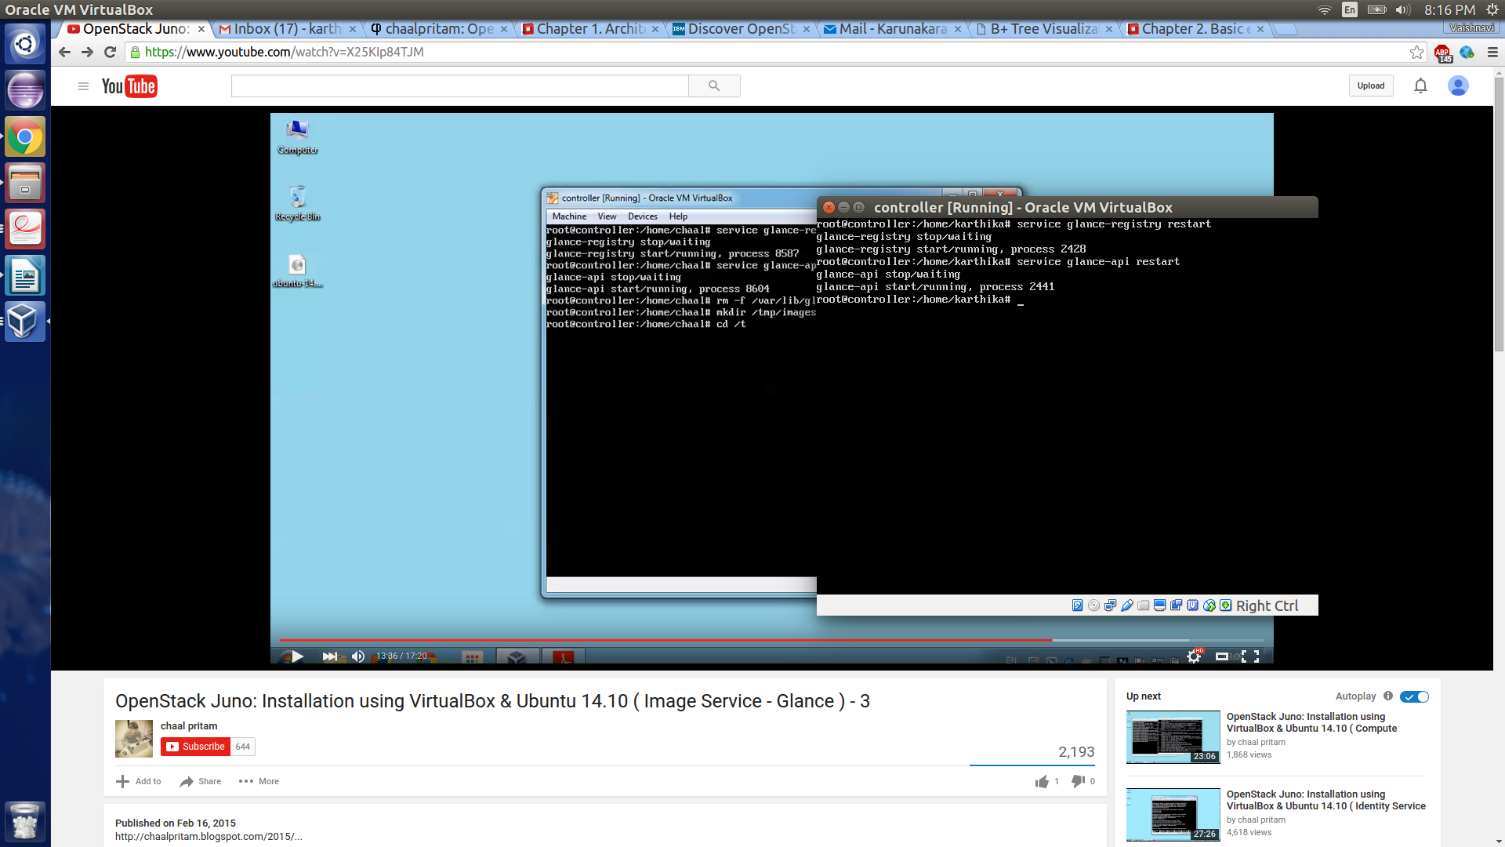

**Service MySQL restart**

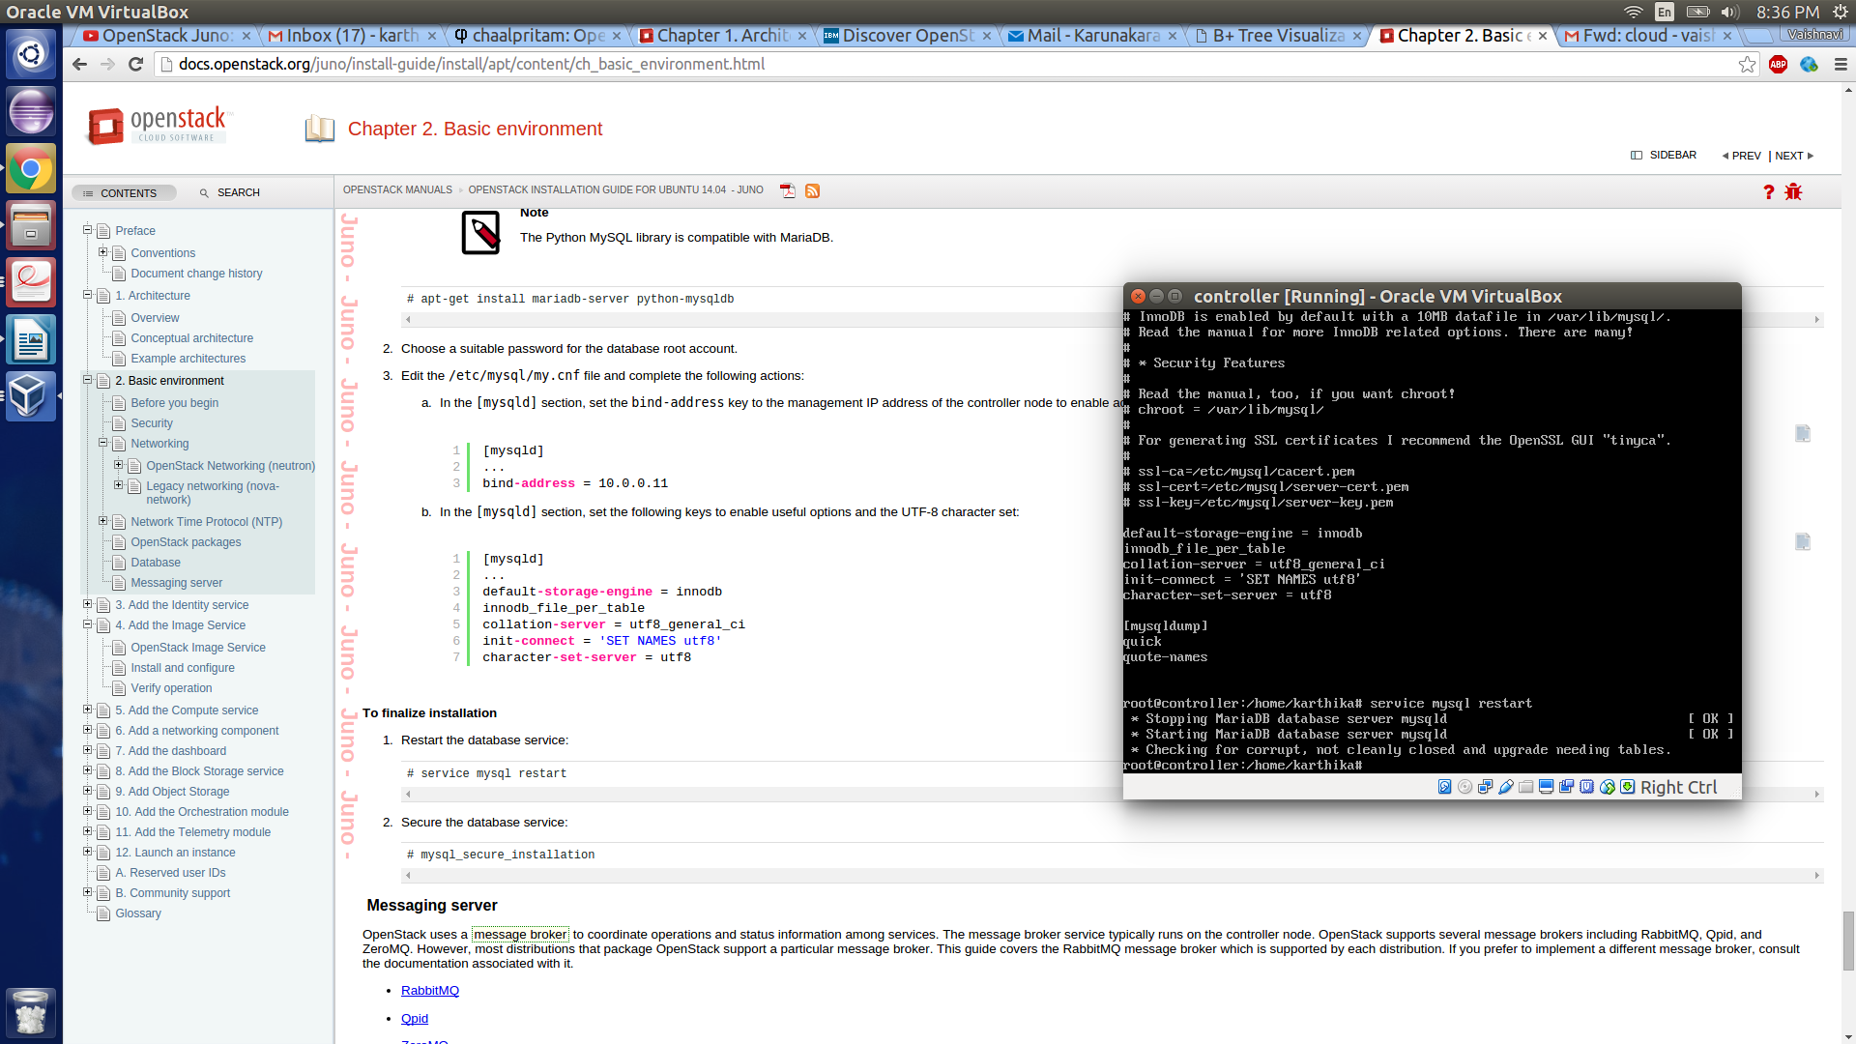

**RabbitMQ server installation and setup**

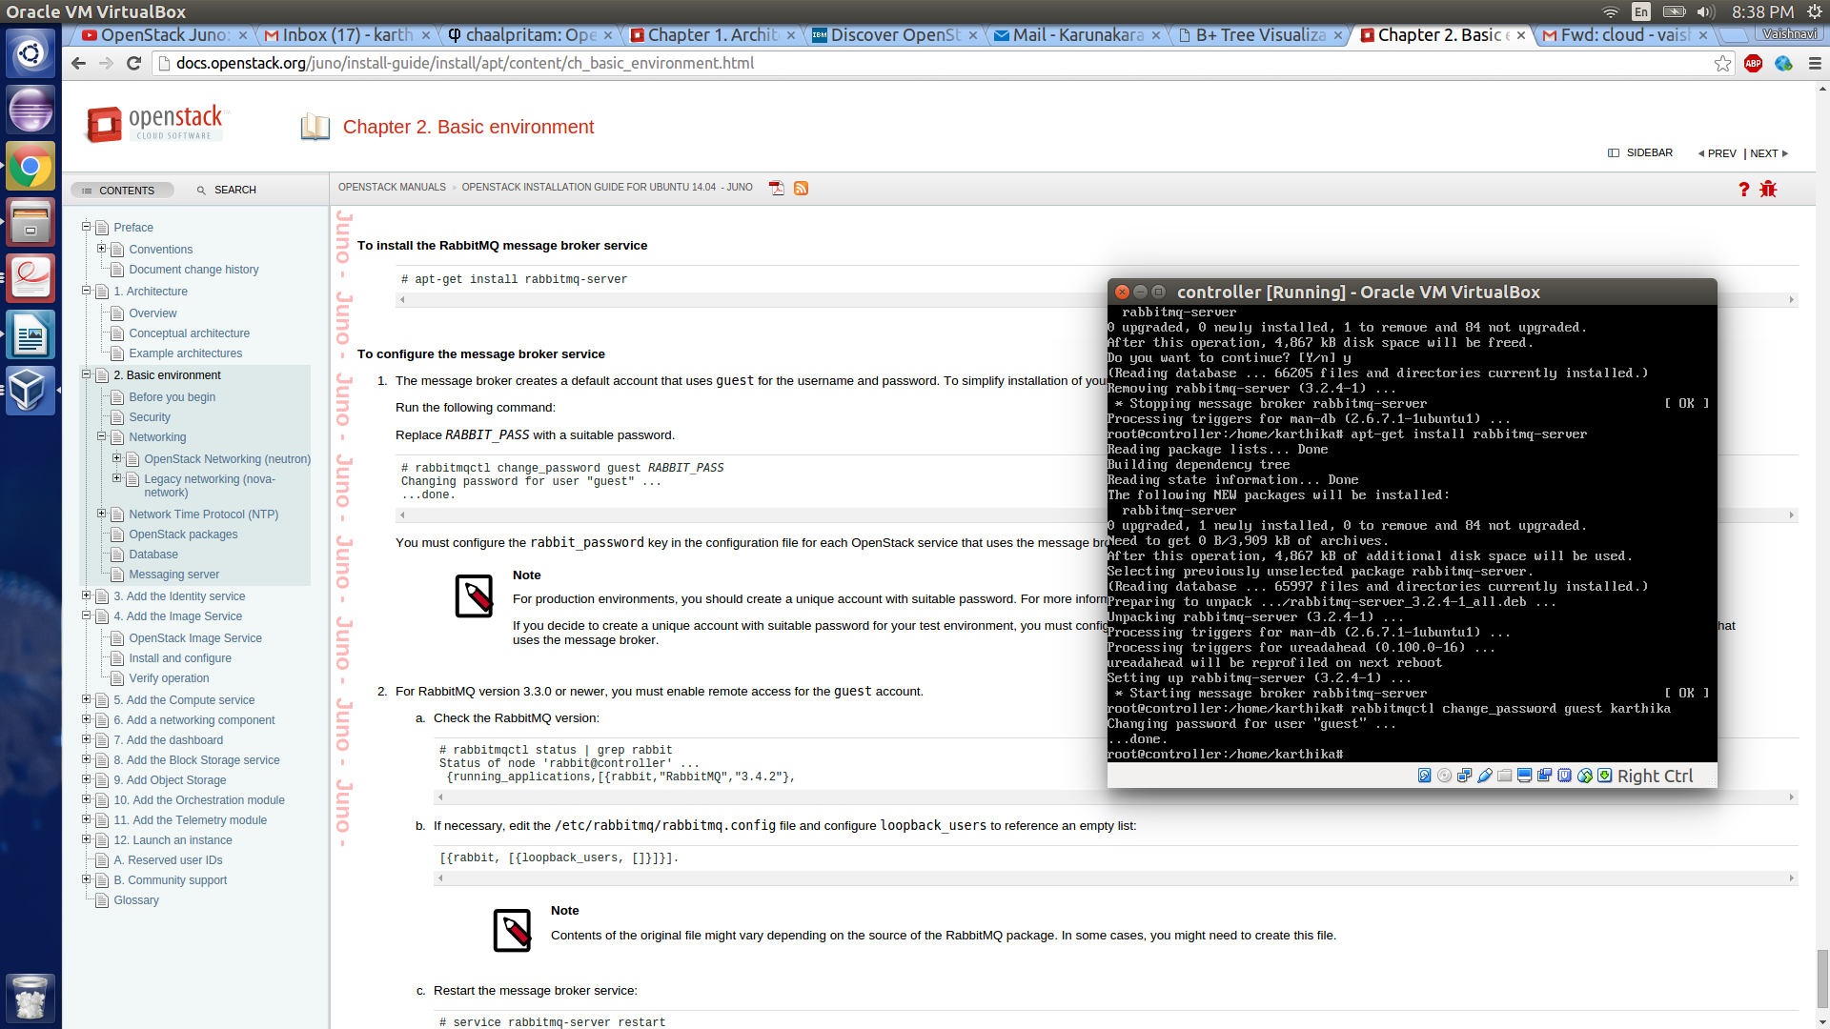

**Install Keystone Client**

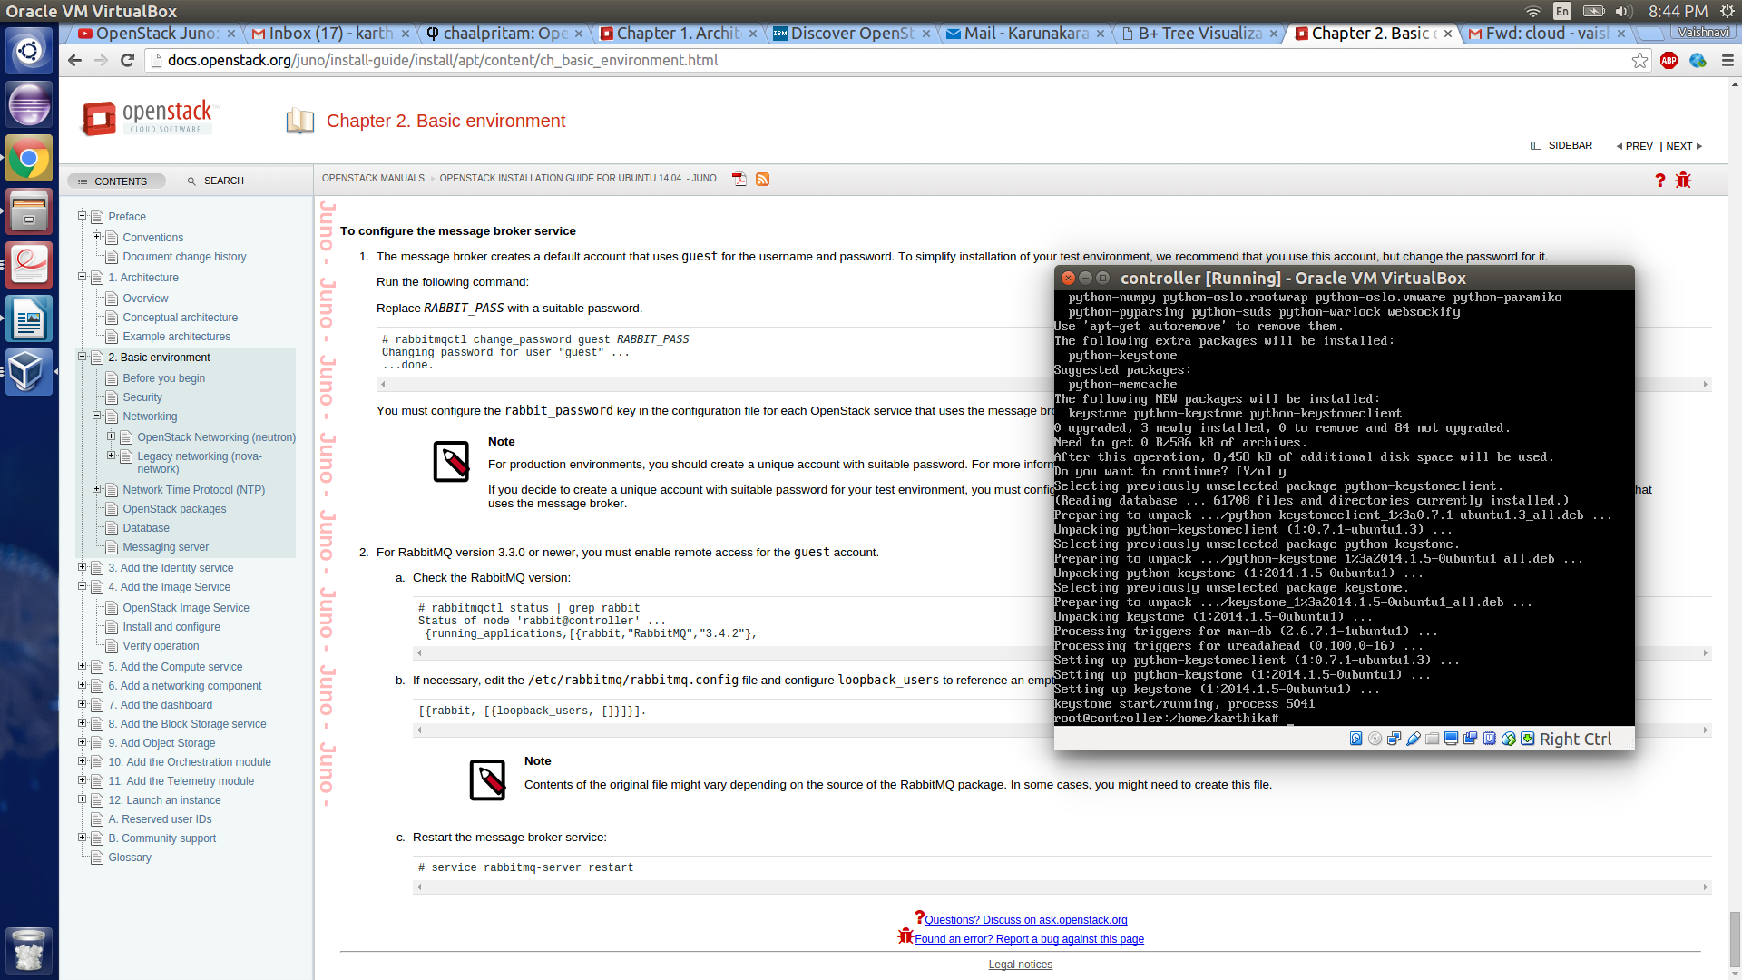

**Keystone Manage Db**

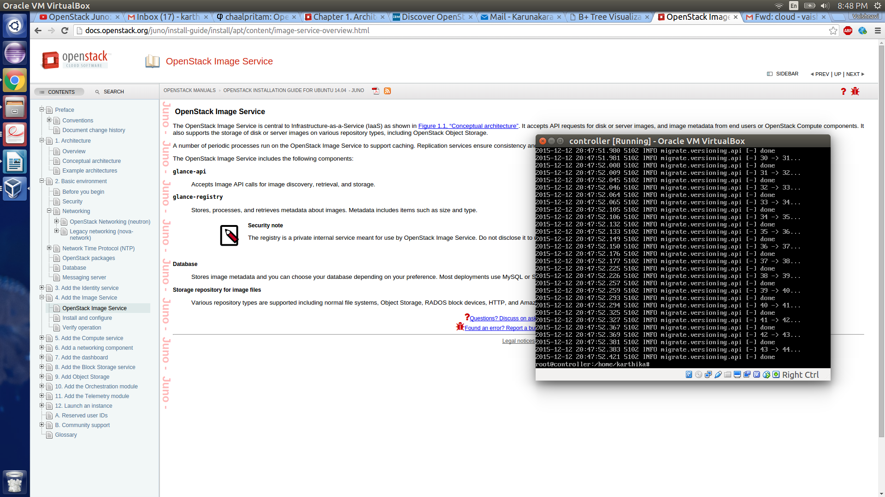

**Admin Tenant keysone**

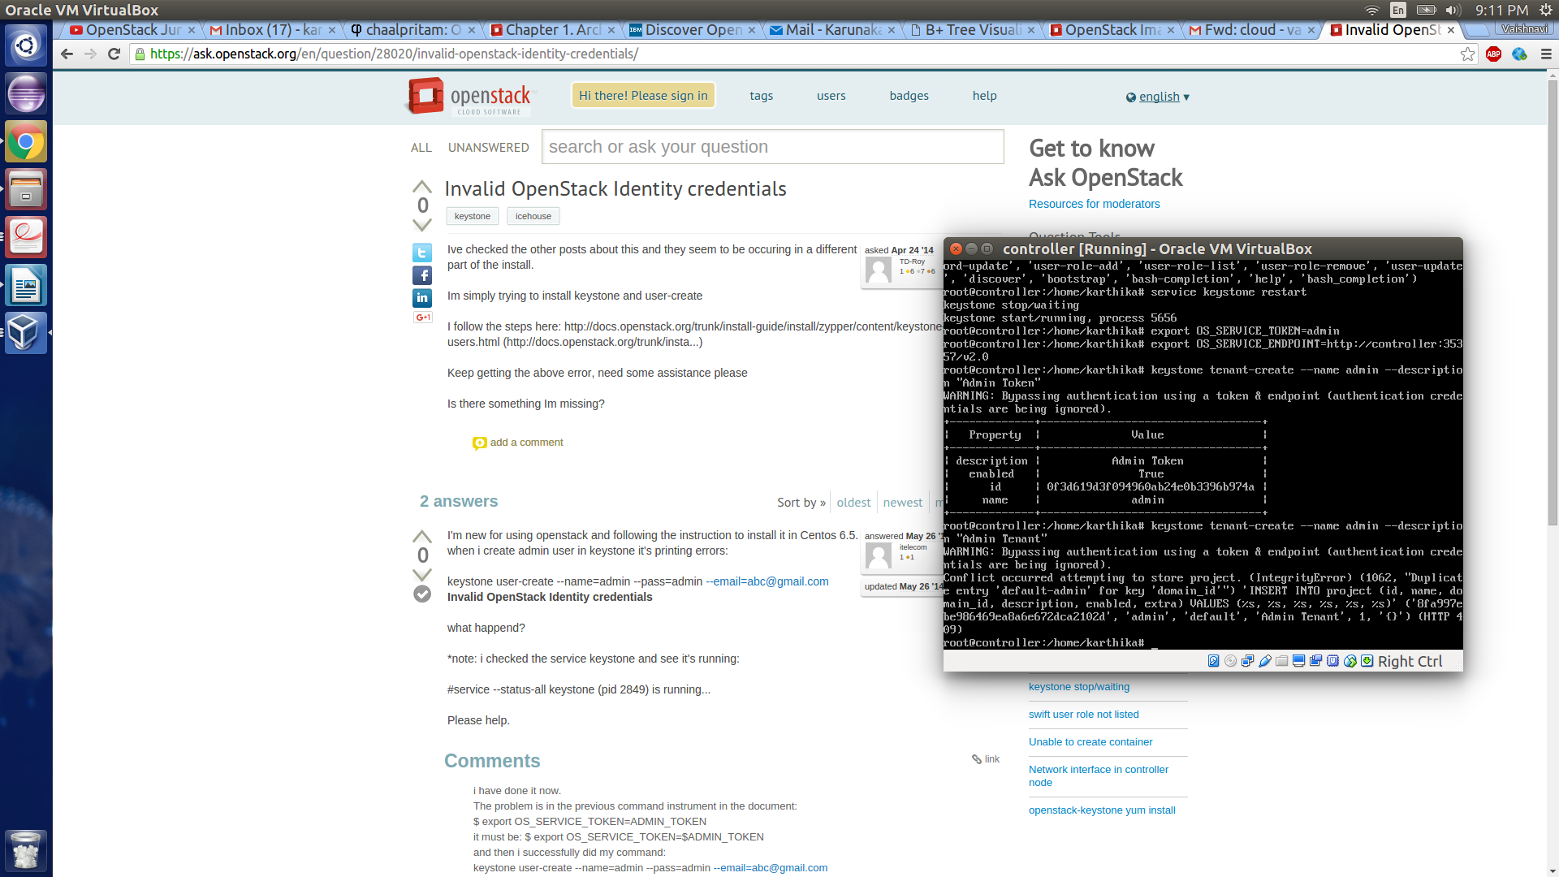

**Keystone Demo**

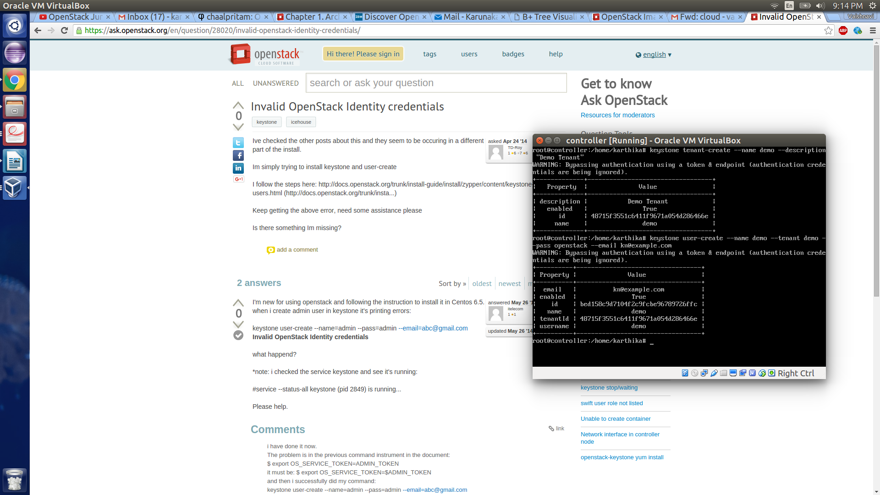

**Create keystone endpoints**

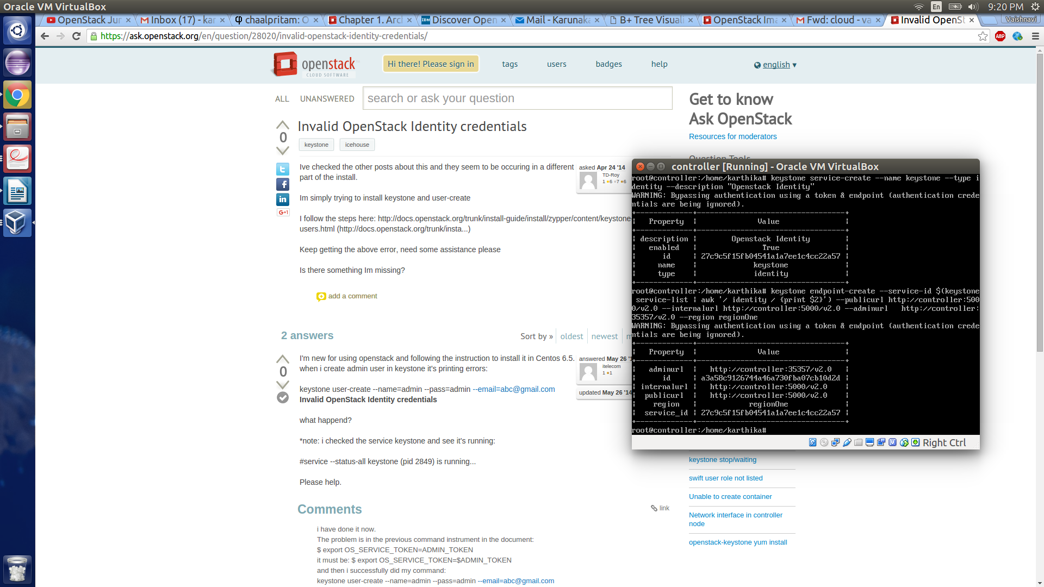

**Keystone role-list**

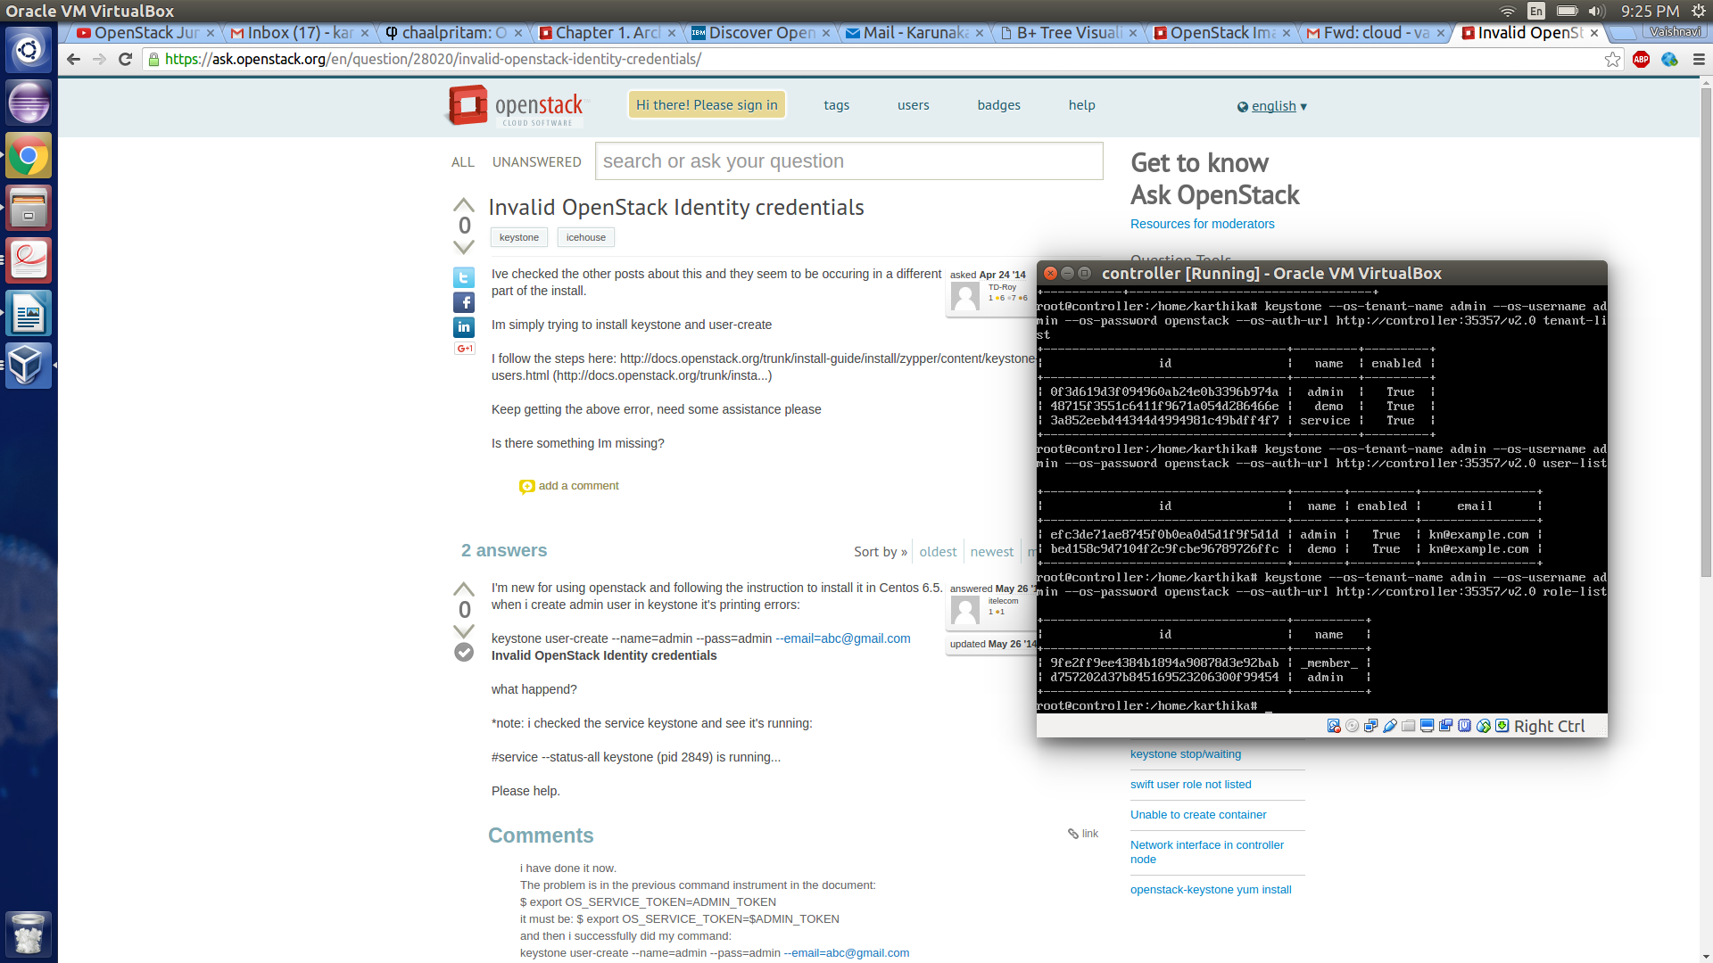

**Demo list**

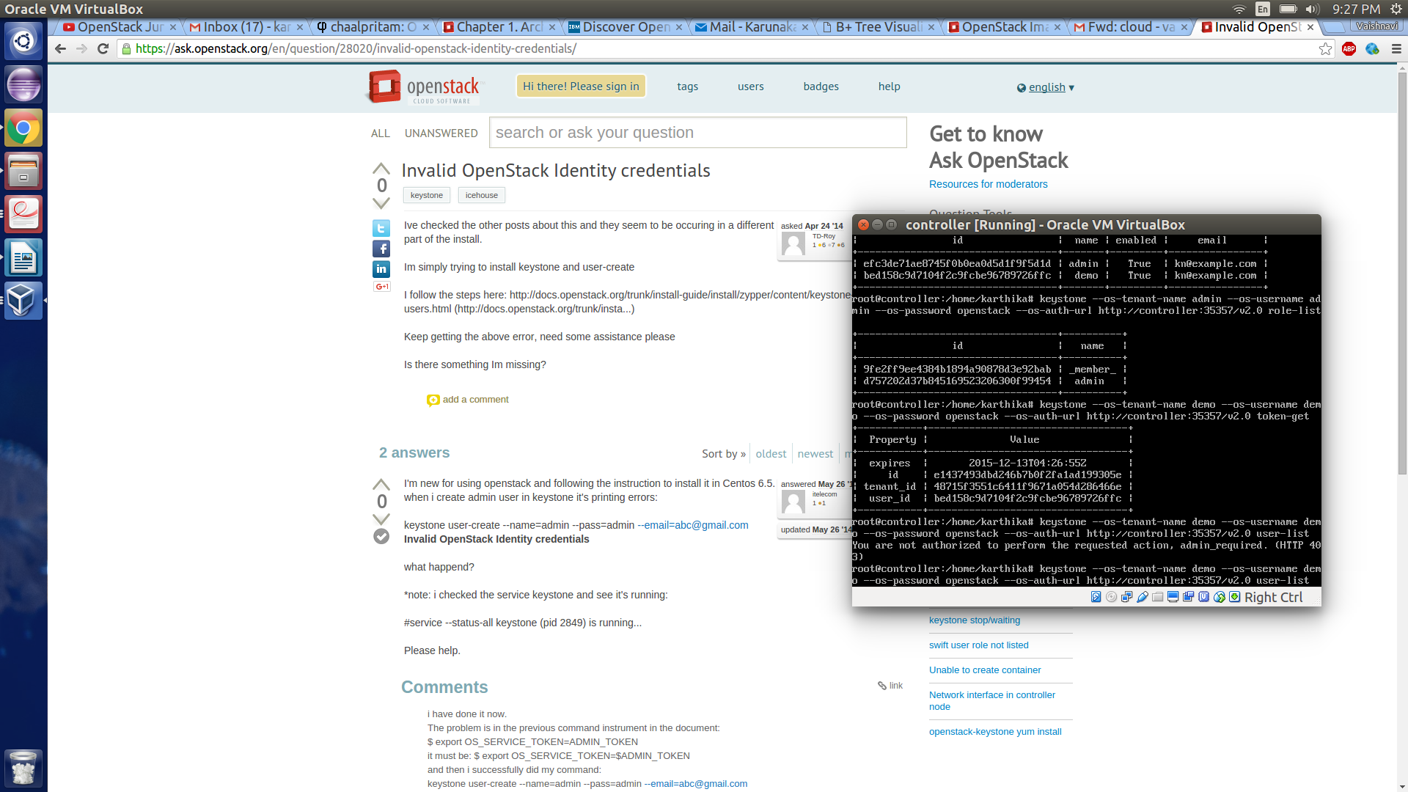

**Create Glance endpoints**

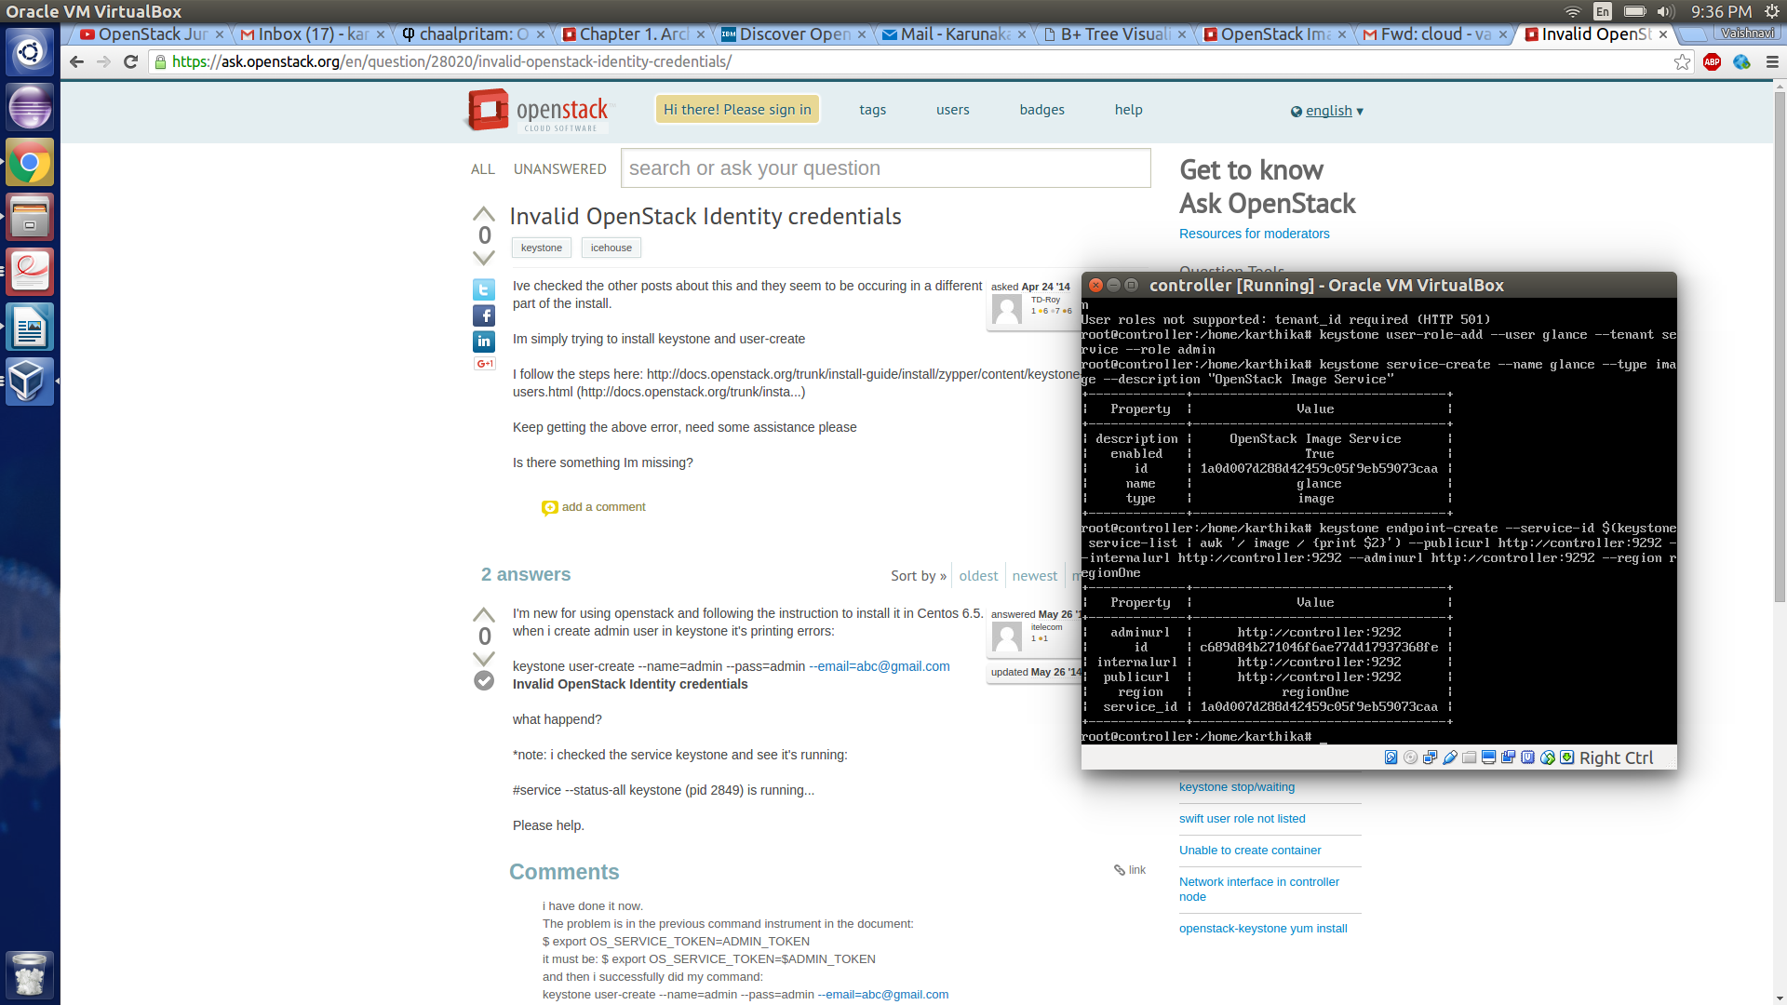

**Glance-manage db sync**

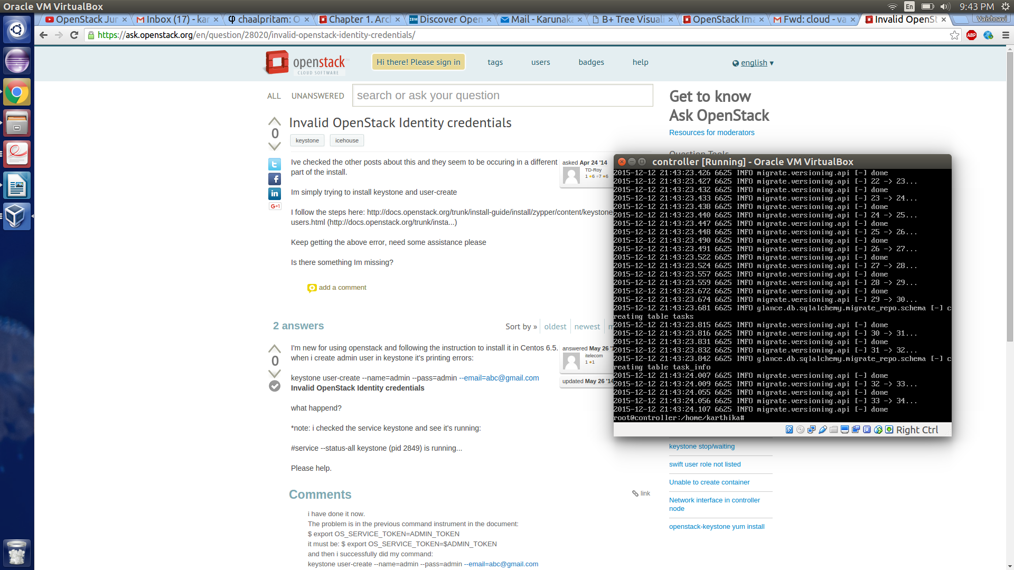

**Glance image endpoint**

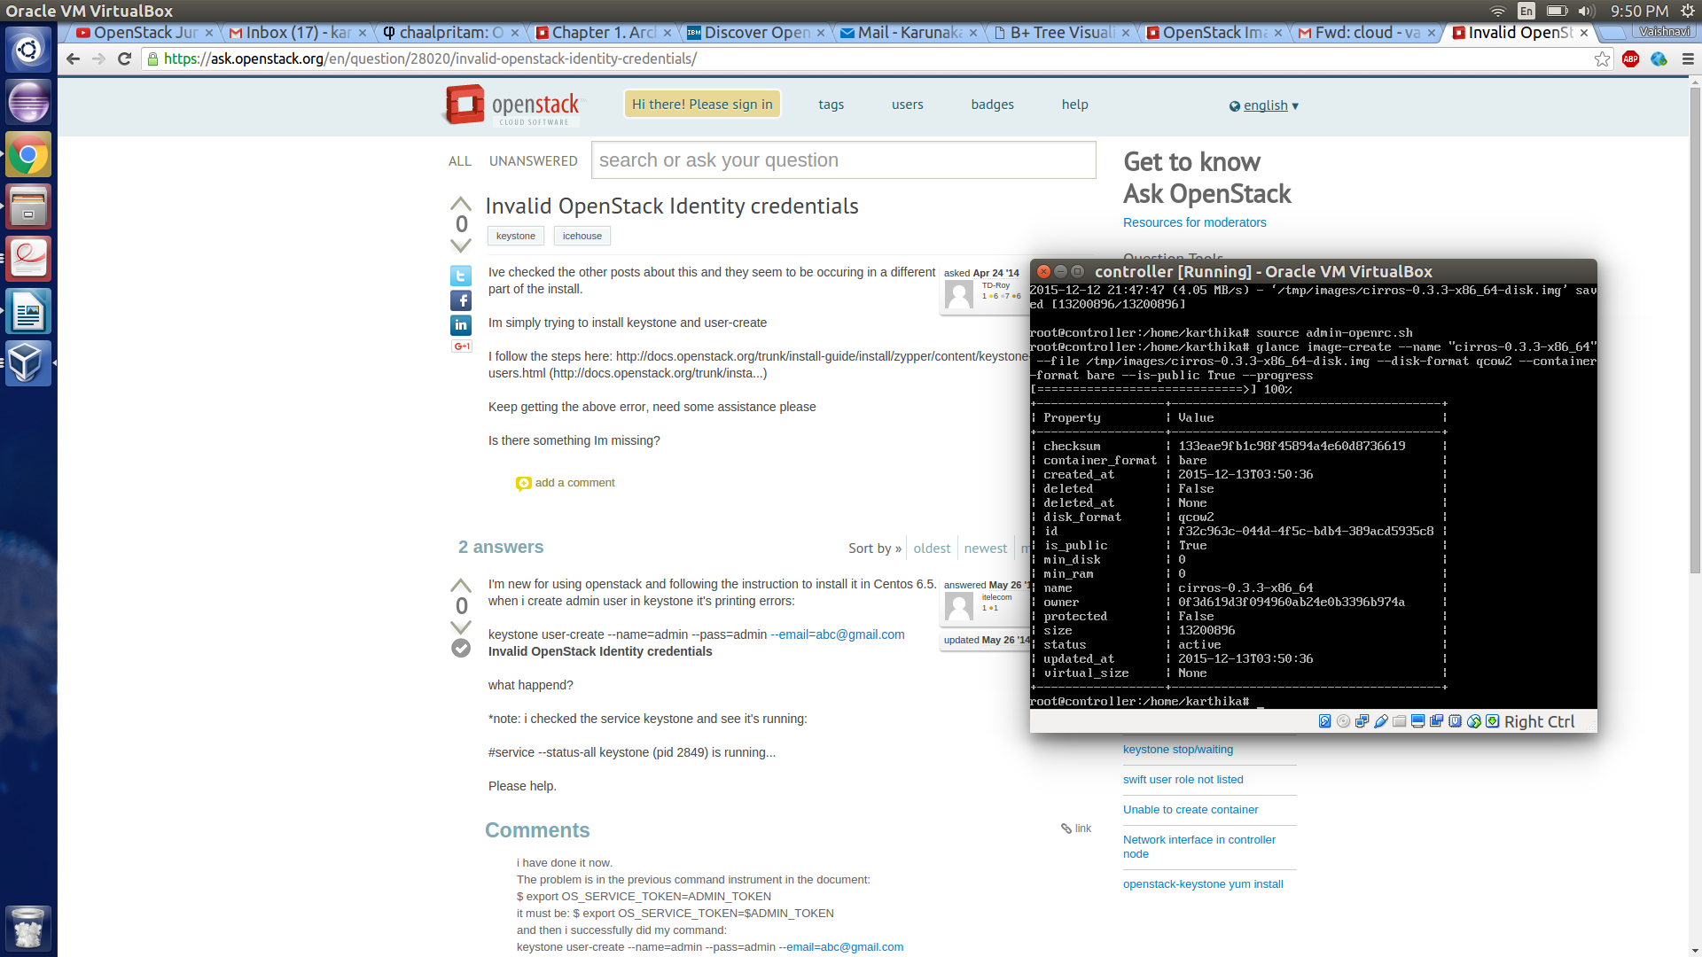

**Glance Image list**

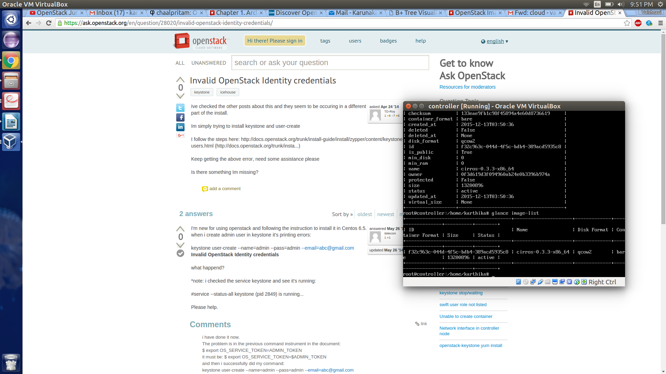

**Create Nova endpoint**

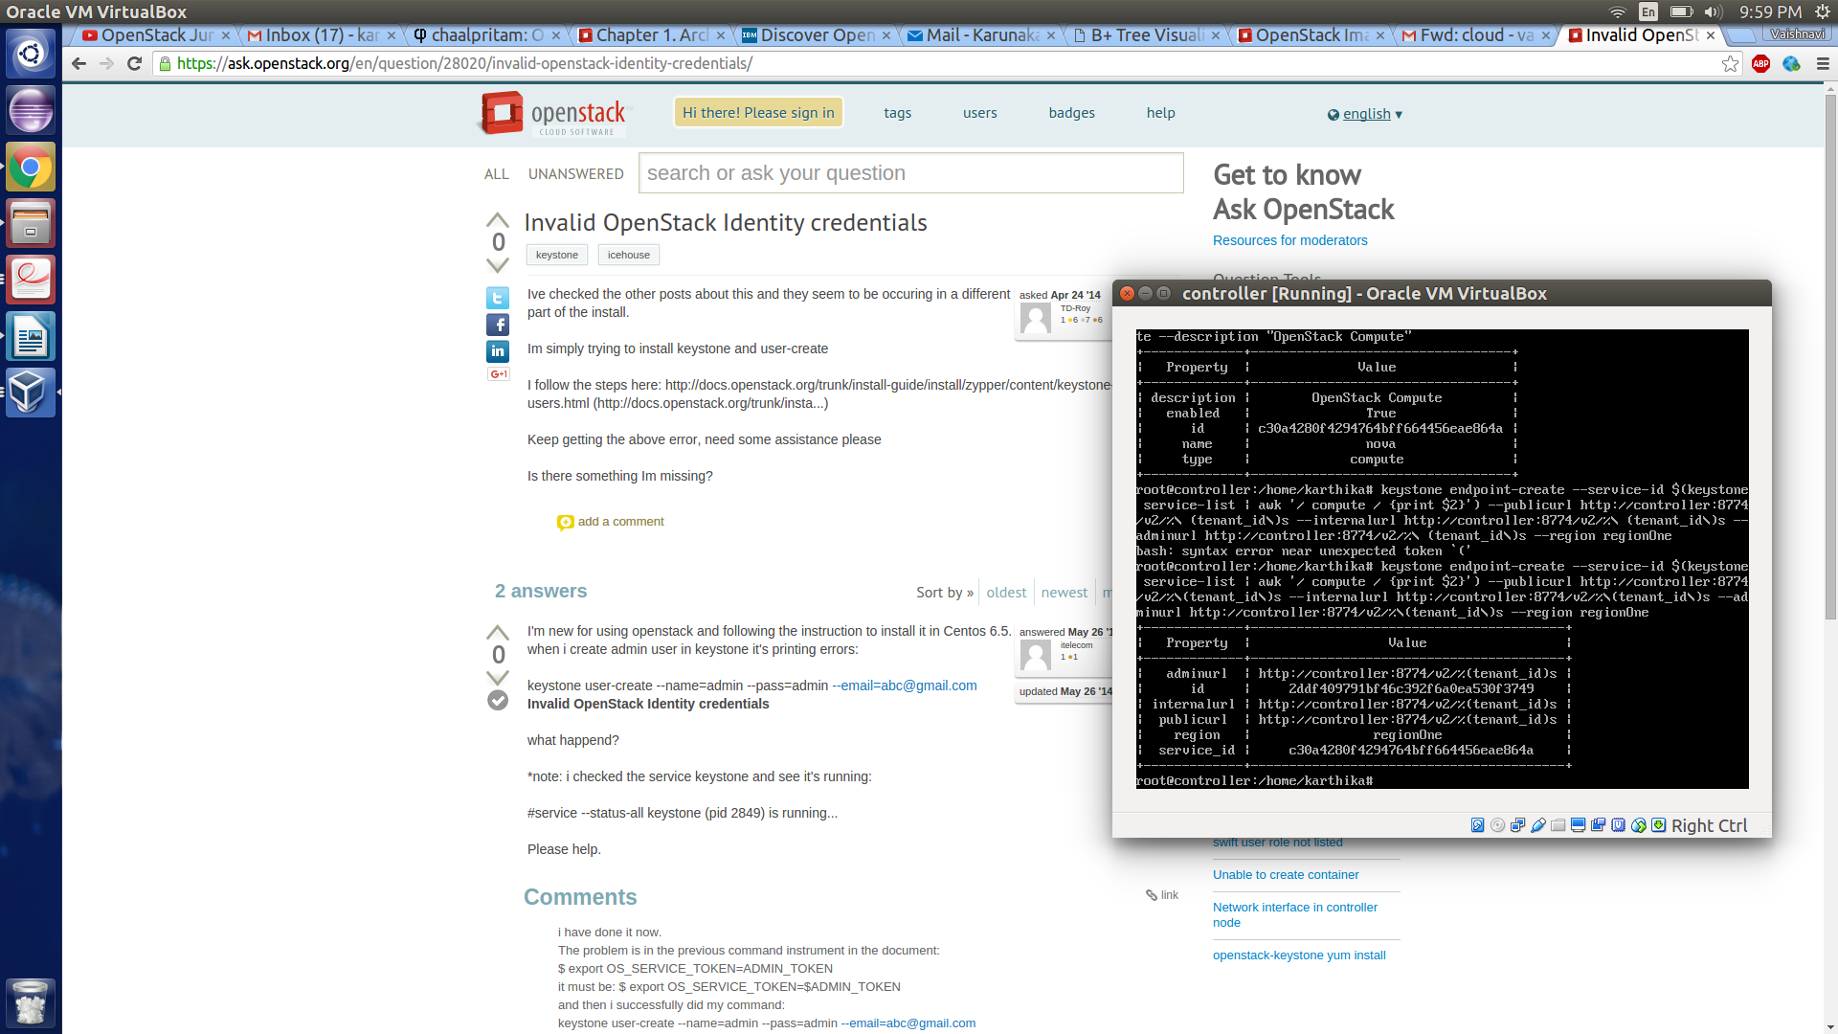

**Service Nova restarts**

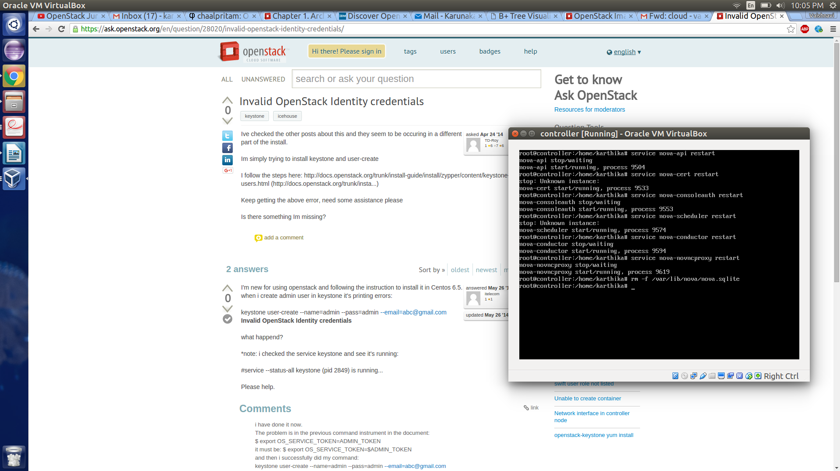

**Nova service-list**

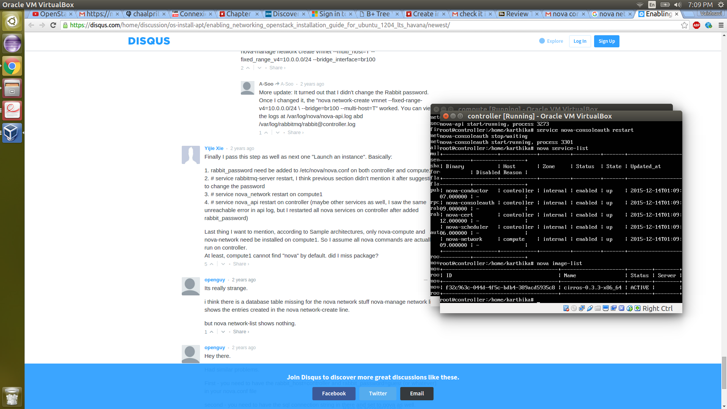

**Nova net-list and security group:**

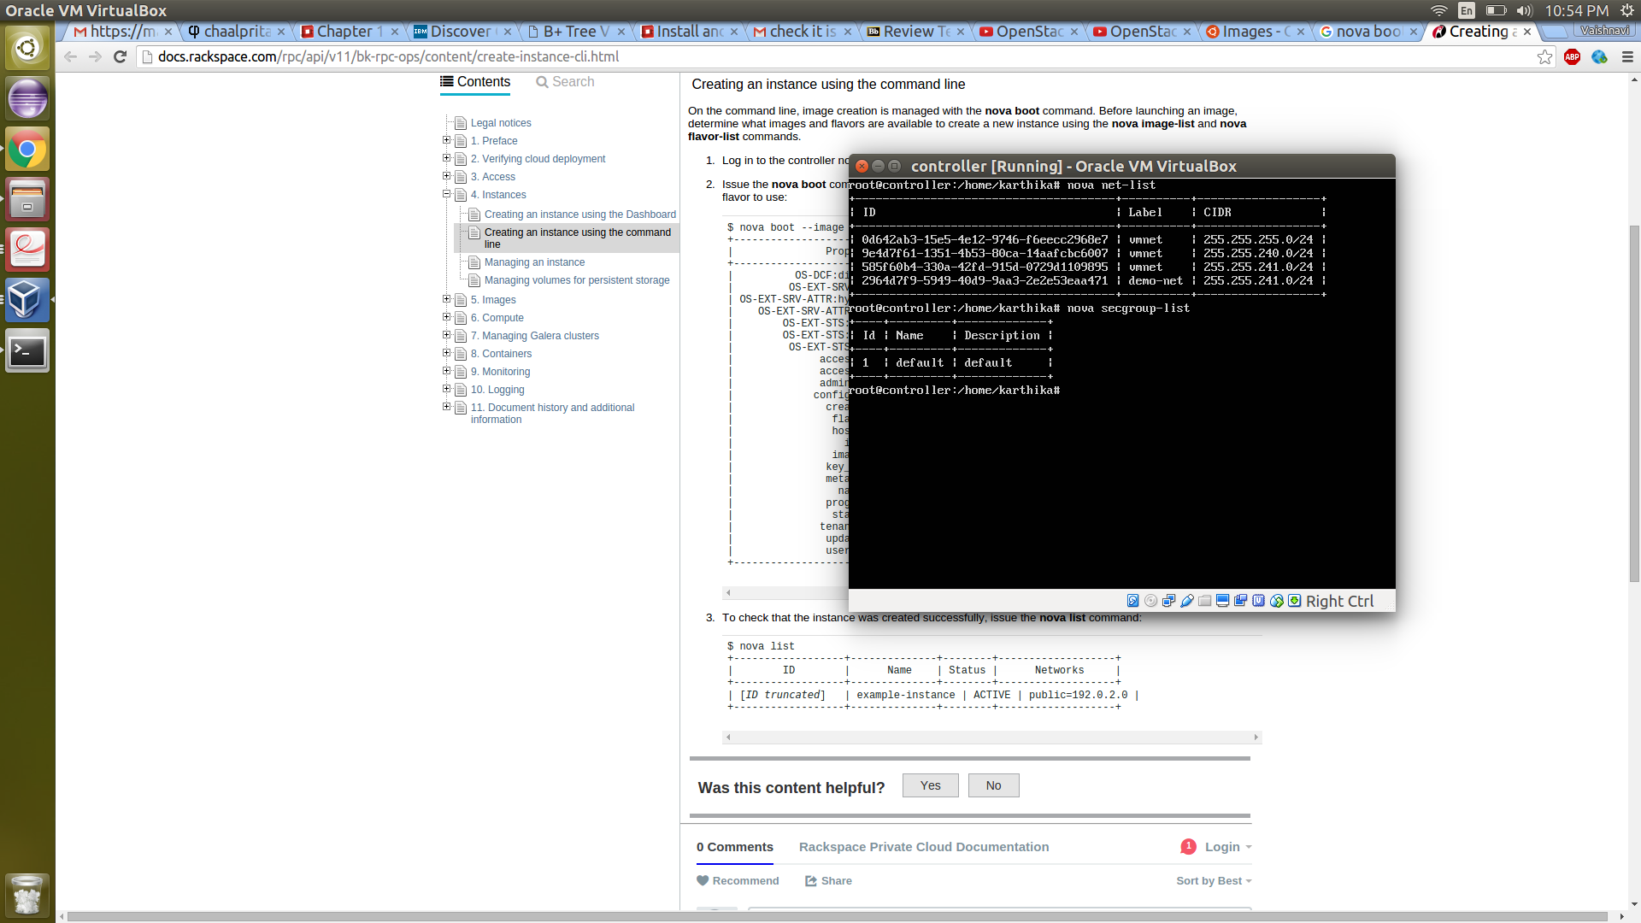

**Horizon dashboard:**

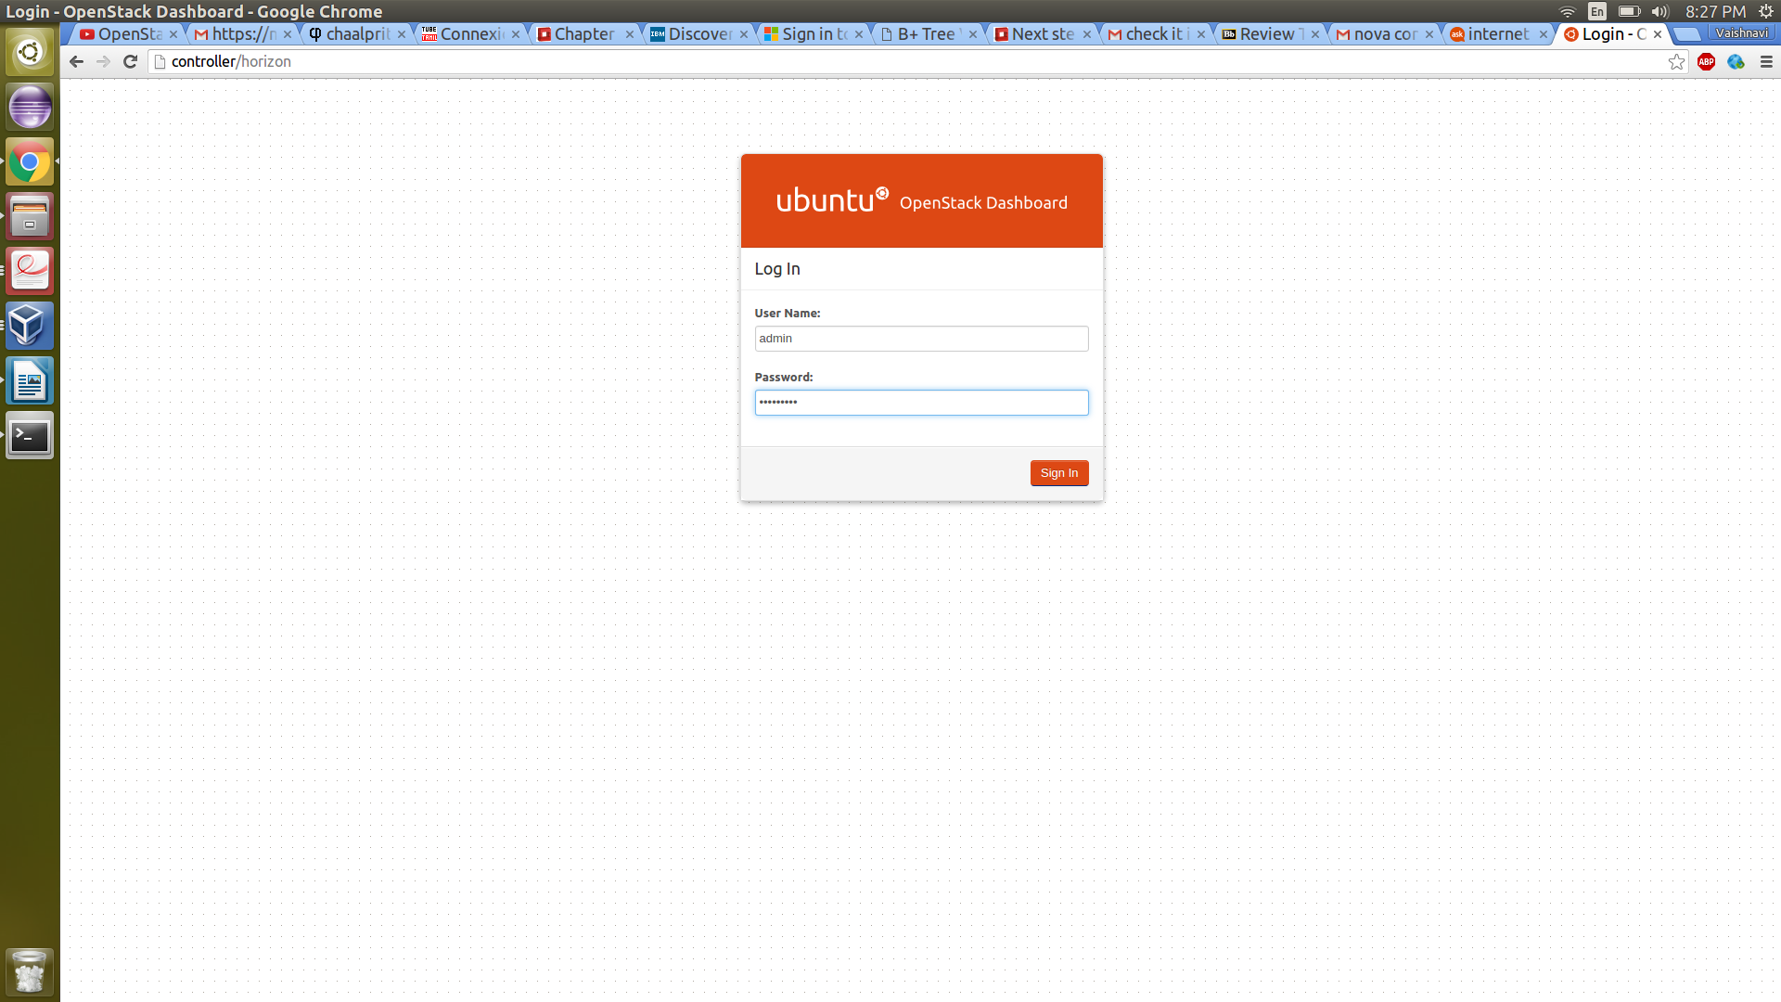

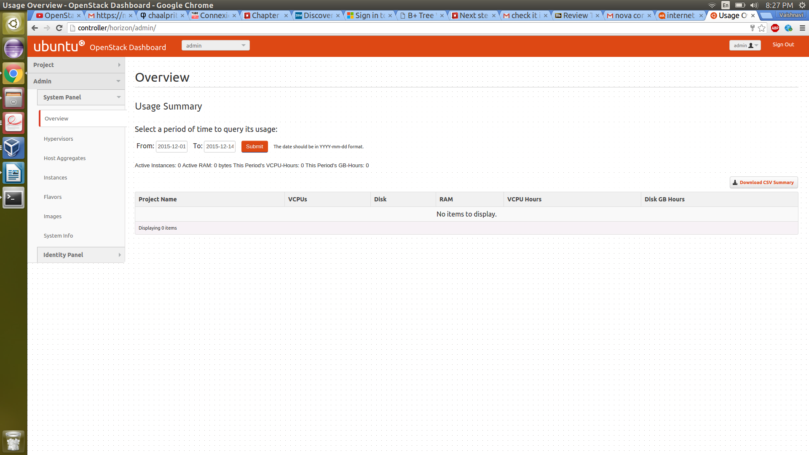

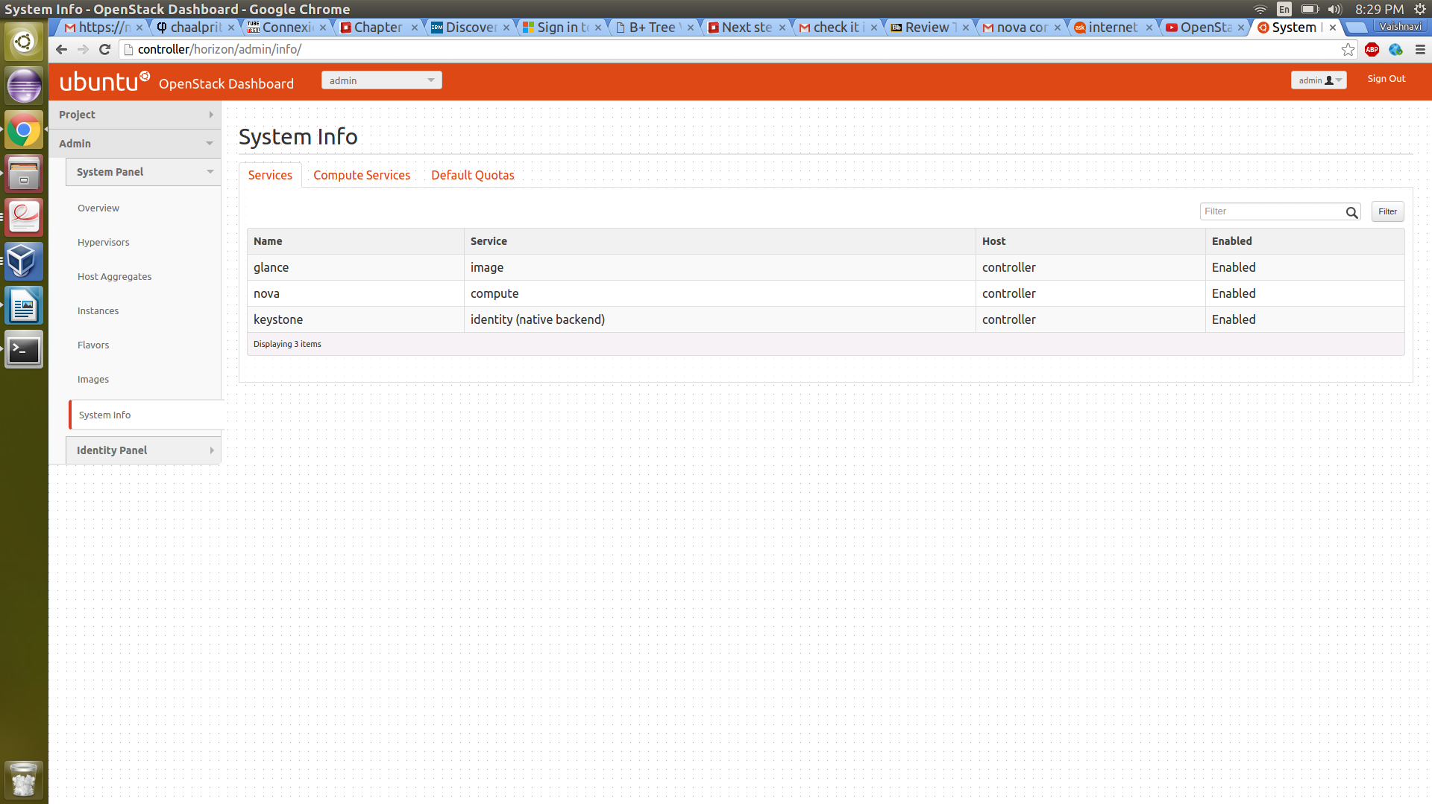

**Nova Key-pair generation:**

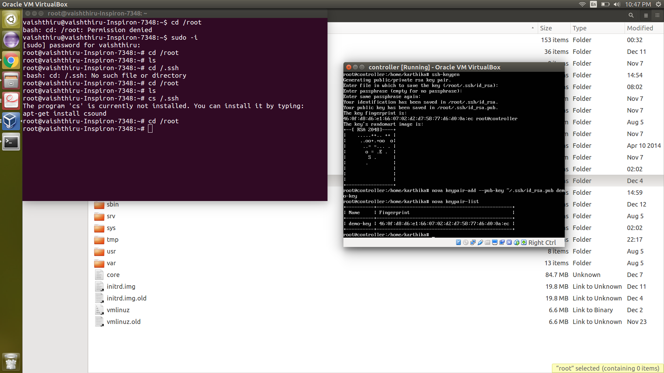

**Nova boot to launch instance:**

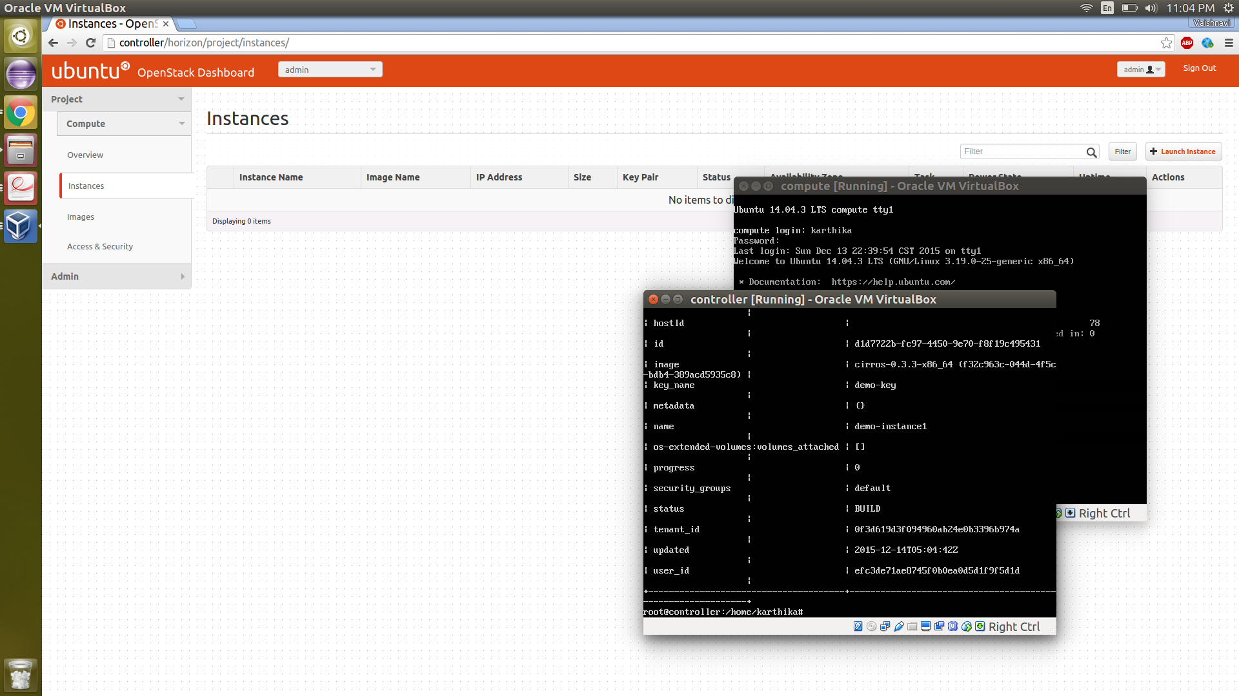

**Launching Instance:**

